USER REPORT

Benefits of 360° connection technology for compressed air
How Böllhoff and BOGE work in synergy

A strong connection – Böllhoff and BOGE have been working closely together for 20 years. Every year, the solution provider of connection technology delivers several hundred thousand elements to the compressed air expert. In close partnership, the two companies from East Westphalia develop new solutions and optimise processes to be state-of-the-art at all times and to guarantee the highest level of customer satisfaction.

Böllhoff is a global partner for 360° connection technology, providing assembly and logistics solutions. The company has been family-run since 1877 and represents long-term success based on innovation and customer focus. As a connection specialist, Böllhoff knows the specific requirements of its customers from all industries and helps them to create successful connection elements. At the Bielefeld headquarters and in the company’s global network, 3,300 employees shape the future of connection technology.

BOGE and Böllhoff: close partners for many years
BOGE and Böllhoff, two companies from East Westphalia, have been working closely together for 20 years. “We are two family-run companies with long traditions. We are known and appreciated in Bielefeld and its surrounding areas as well as all over the world for our innovative products and services”, reports Marcel Rupprecht, Managing Director of Böllhoff GmbH. “Both companies are constantly further developing their products with the goal of supplementing customer requirements with promising approaches.” Based on the service concept, Böllhoff created the ECOTECH Service 20 years ago to increase customer satisfaction. This is an engineering consulting service where qualified specialist screw engineers have close contact with customers like BOGE. Comprehensive consultation also includes expertise provided by Böllhoff. This is designed to help customers understand products in order to be able to assess opportunities and limitations of their use. The goal is a lasting partnership with continuing support.

Expert support for the entire product life cycle
With their comprehensive, specific knowledge, Böllhoff’s specialists have a distinctive perspective when it comes to connection technology requirements in numerous applications. Analysis of data and information relating to material and screw depth as well as assembly processes and other aspects are the foundation for choosing and evaluating possible screw geometries. This allows the correct decisions to be made with regard to suitable connection elements. Assembly workplaces and processes are inspected thoroughly to highlight the potential for improvement. “The earlier we’re included in development processes, the better the results will be”, explains Daniel Tovar Escolar, Head of Product Management and Application Technology. “That’s why it makes sense to arrange a consultation for the beginning of a project, rather than when problems occur.” Böllhoff’s support starts as early as product development to ensure shorter Time-to-Market. As part of the company’s development services, the specialist is responsible for finding the appropriate connection element, while customers can focus fully on their core competencies without losing valuable time. Böllhoff uses FEM analyses and other calculation tools. The company also has its own test laboratory that includes a test area, for example, to conduct vibration testing. Other methods, such as Tear-Down analyses, CAE applications and the use of mobile test devices, are also part of the service the expert in connection technology provides.

Targeted control of material requirements via Kanban
“Almost all of BOGE’s compressors include products provided by Böllhoff”, explains Kevin Kammerer, Head of Machine Development at BOGE. “In the last 10 years alone, Böllhoff has delivered more than 27 million connection elements to BOGE.” Owing to the production process control via Kanban, the repeat order of screws and other connection elements is automatic. In this way, required components are provided at the right time in the right quantity. The Kanban system is particularly beneficial when re-acquiring C parts. “Of course, it would be disastrous if BOGE’s production was to come to a halt because some simple hexagon screws are missing”, Daniel Tovar Escolar points out. “Thanks to our procurement and delivery system ECOSIT® (ECOnomic Supply In Time), parts availability is always guaranteed.” Böllhoff even delivered reliably during the coronavirus pandemic.

Comprehensive testing of BOGE compressors
To optimise processes and products, Böllhoff initially carried out a comprehensive situation analysis for BOGE. During an onsite tour, the solution provider of connection technology examined screwing and assembly processes in the compressed air expert’s production department. Over the course of the past years, several different projects were implemented. The DST quick-release fastener, for example, is installed in two compressor models to make assembly processes easier for service technicians and to prevent mistakes during assembly. The quick-release fastener is based on Snap-Technology. The fastener snaps into position similar to a door lock. Metal sheets of different thicknesses can therefore be connected in a vibration-resistant way without having to be screwed together. This aspect makes assembly processes much easier for BOGE technicians who can quickly get to components on the inside of machines when maintenance is required, even in areas that are hard to access. The DST connection is also suitable as a substitute for blind rivet nuts or as a replacement for centring pins as well as screws and nuts in numerous BOGE models. In addition, Böllhoff’s screw lock elements ensure increased safety for components that are subjected to dynamic loads. These and other applications are currently being tested in a compressor.

Increasing cost benefits and process safety
“We pride ourselves on always keeping our technology updated, which works perfectly, thanks to our co-operation with Böllhoff”, emphasises Olaf Hoppe, Managing Director of BOGE. “We are continuously implementing optimisations and further developments to expand our technology leadership.” BOGE also relies on process safety and is interested in solutions that prevent incorrect assembly. Servicing, too, is made easier by using suitable connection elements. Optimisations in the area of connection technology allow the reduction of components and minimisation of tool costs in production. A specific example is the use of flange screws. These screws feature an extended surface under the head that allows even pressure distribution. This creates a secure connection. Thanks to the flange, no washers are needed – a huge advantage compared with conventional screw connections with screw, nut and washer. Using flange screws not only results in cost savings but also in increased safety during assembly processes because the technician cannot accidentally forget the washers.

A classic win-win situation
“We are thrilled by Böllhoff’s 360° service”, summarises Kevin Kammerer “This ranges from product presentations, production line tours and workshops on what is known as TechDays and detailed inspections in test labs to digital product consultation that can be used to find the appropriate screw connection online, quickly and without hassle.” Both companies complement each other in their co-operation. They share and practise the same values and are deeply rooted in the region. As system providers, they are characterised by reliability and top product quality. In all this, they prioritise focus on customer benefits. They develop new products together and optimise existing processes to meet customer needs even more effectively. “Our co-operation with BOGE is very valuable”, highlights Daniel Tovar Escolar. “We don’t have a classic customer/supplier relationship but we both benefit from sharing fruitful ideas. This partnership creates the perfect opportunities to get the best out of the compressors and to find ideal connection elements.” The proximity of the two companies’ headquarters allows uncomplicated, fast and focused co-ordination.

Length: X,XXX characters including spaces
Updated: 16 February 2024

Images: 4, source: BOGE
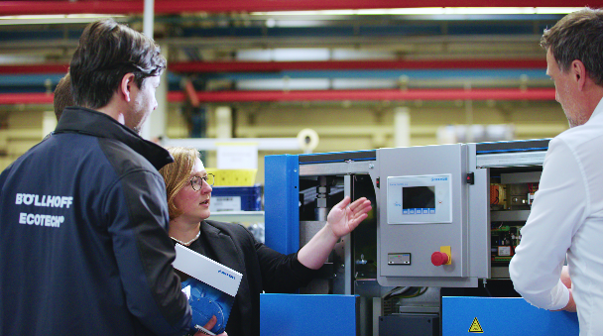
Caption 1: To optimise processes and products, Böllhoff initially carried out a comprehensive situation analysis for BOGE. During an onsite tour, the solution provider of connection technology examined screwing and assembly processes in the compressed air expert’s production department.

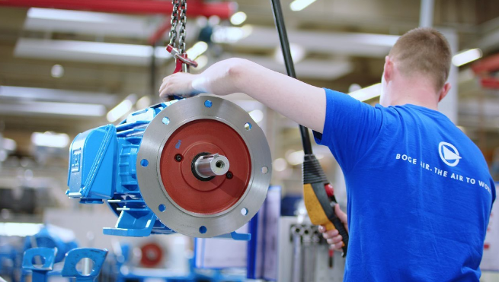
Caption 2: A strong connection – Böllhoff and BOGE have been working closely together for 20 years. Every year, the solution provider of connection technology delivers several hundred thousand elements to the compressed air expert.

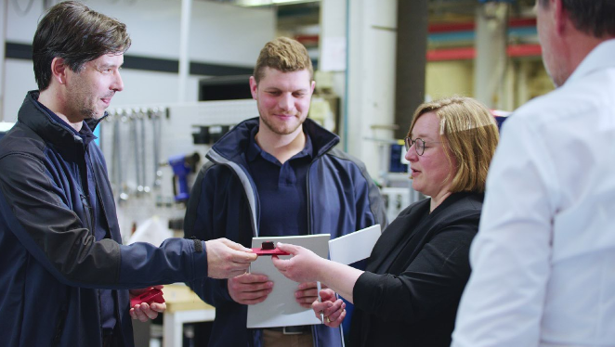
Caption 3: In close partnership, the two companies from East Westphalia develop new solutions and optimise processes to be state-of-the-art at all times and to guarantee the highest level of customer satisfaction.

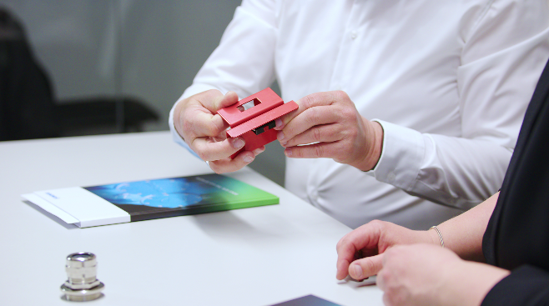
Caption 4: Optimisations in the area of connection technology allow the reduction of components and minimisation of tool costs in production.

Über BOGE
Mit der Erfahrung von mehr als 115 Jahren gehört die BOGE KOMPRESSOREN Otto Boge GmbH & Co. KG zu den ältesten Herstellern von Kompressoren und Druckluftsystemen in Deutschland. Das Unternehmen ist einer der Marktführer. Ob Schraubenkompressoren, Kolbenkompressoren, Scrollkompressoren oder Turbokompressoren, komplette Anlagen oder einzelne Maschinen – BOGE erfüllt unterschiedlichste Anforderungen und höchste Ansprüche. Präzise und qualitätsbewusst. Das international tätige Familienunternehmen beschäftigt rund 800 Mitarbeiter und wird von Olaf Hoppe und Michael Rommelmann geführt. Seinen internationalen Kunden bietet BOGE mit zahlreichen Verkaufsbüros und Tochtergesellschaften einen umfassenden Service. Das Unternehmen liefert seine Produkte und Systeme in weltweit mehr als 120 Länder.

BOGE company contact
Christian Schlüter
Head of Marketing
Phone: +49 5206 601-5830
Fax: +49 5206 601-200
Email: C.Schlueter@boge.de

Agency press contact
Lina Sophie Schmidt
additiv
An additiv pr GmbH & Co. KG brand
B2B communication for logistics, robotics, industry and IT
Herzog-Adolf-Straße 3
56410 Montabaur
Germany

+49 2602 950 99 29
ls@additiv.de
additiv.de

